**INNOVATIVE PRODUCT DESIGN (IPD**)

**PROJECT FILE**

**PUMATE**



Session 2018-2019

SUBMITTED TO :- Submitted By:-

Dr. Sukhvinder Singh Bamber Gaurav Anand (SG18318)

Assistant Professor Chandan Bansal (SG18313)

Naveen Dogra Akshay Krity (SG18306)

Assistant Professor

**DEPARTMENT OF COMPUTER SCIENCE AND ENGINEERING (B.E)**

(U.I.E.T) PANJAB UNIVERSITY SWAMI SARVANAND GIRI REGIONAL CENTRE

HOSHIARPUR - 146021, PUNJAB (INDIA)

**Table of Content**

|  |  |
| --- | --- |
| **CONTENTS** | **PAGE-NO** |
| 1. Declaration | 3 |
| 1. Acknowledgement | 4 |
| 1. System requirement specifications | 6 |
| 1. Introduction to HTML language | 7-10 |
|  | 11 |
| 1. Description | 12 - 17 |
| 1. Source code | 18 - 25 |
| 1. Glimpses of the game | 26 - 34 |
| 1. Future scope | 35 |
| 1. Conclusion | 36 |
| 1. Reference | 37 |

|  |  |
| --- | --- |
|  |  |

**DECLARATION**

The work embodied in the training report entitled, **“Pumate”** submitted to the department of UIET at Panjab University Swami Sarvanand Giri Regional Centre, Hoshiarpur for the award of degree of Bachelor of Engineering in the branch of Computer Science and Engineering has been done by us. The project/training is entirely based on our own work and not submitted elsewhere for the award of any other degree. All ideas and references have been duly acknowledged.

Name of Students:-

Gaurav Anand

Chandan Bansal

Akshay Krity

## **Acknowledgement**

The success and final outcome of this project required a lot of guidance and assistance from many people and we are extremely privileged to have got this all along the completion of our project. All that we have done is only due to such supervision and assistance and we would not forget to thank them.

We respect and thank all the teachers, for providing us an opportunity to do the project work in [CSE Lab] and giving us all support and guidance which made us complete the project duly. We are extremely thankful to her/him for providing such a nice support and guidance.

We would like to thank our branch coordinator Mr Naveen Dogra. We owe our deep gratitude to our project guide Mr Vivek Sood, who took keen interest on our project work and guided us all along, till the completion of our project work by providing all the necessary information for developing a good system.

We are thankful to and fortunate enough to get constant encouragement, support and guidance from all Teaching staff of Computer Science Department which helped us in successfully completing our project work. Also, we would like to extend our sincere esteems to all staff in laboratory for their timely support.

Gaurav Anand

Chandan Bansal

Akshay Krity

1. **INTRODUCTION:-**

Pumate is the common platform for the students as well as others to explore everything related to college`s academics, live, past and upcoming events,

Alumni and many more.

1. **PURPOSE:-**

The purpose is to provide a single platform for the students and faculty to access and share everything related to college.

1. **TARGET AUDIENCE:-**

The target audience for our website are the people related to college.

Almost every information is available at the website like syllabus, question paper, notice, photo gallery, faculty & alumni details, upcoming and past events and many more things to explore regarding college .

1. **SCOPE:-**

This Website provides a better interface between our students and college administration. Lot of people can connect through visiting the site, to know more and more about the college.

1. **PROJECT OBJECTIVES:-**

The objective of the project is to build a breeze among student , faculty members and alumni of the college, and providing every thing on a single window.

* 1. **GOALS:-**

As like of any project the very first goal is to complete the work on time, all the functionalities, working and with proper testing and bug fixings. Now coming to the other goals, the list is as follows:

1. Responsive Web Design
2. Tawk.to API
3. Google Maps API
4. Payment gateway
5. Caraousel
6. Use of Jquery, bootstrap and javascript
   1. **TASKS:-**
7. **Proper Environment Setup:**

Before stating the actual coding, it is necessary that we should first set up the Development Environment for the whole team. It involves installing softwares and adding Content delivery Network Links to the required sites in the project. The list is as follows:

a.1) Adobe Photoshop

a.2) Visual Studio Code

a.3) Atom text editor

a.4) Bootstrap CDN links

a.5) JQuery plugin links

a.6) Git for version Control

a.7) GitHub Desktop

a.8) Team viewer

1. **Frame Work Building:**

Even after the environment setup we could not start the core coding because the very next requirement is to build the frame work of the website which involves things like total number of pages, layout of every single page, which functionality should work on which page and how we are going to implement it and more things.

1. **Designing:**

Now, after when the frame work building is completed, the next step is to make a beautiful design because whenever a coder starts the coding, he/she should not think about the design because it will ultimately reduce the efficiency of the coder. Not only this reason, design is very important for the website because everything in this world is first determined by the looks. If looks are not good, one is not going to like it and in our case if the looks of our website are not good, then visitors are not going to visit the website.

1. **Coding:**

This section involves the core development of the website that is the coding. As now layout and design is ready, coders can start working on the project. The most important and necessary thing for Web Developer is to build the website as is it is to the design given by the Web Designer.

1. **Testing:**

Ohh, now as the development of the website is completed it’s the time for the Tester to start working. Testing can be done manually or automated. In our case we have done it manually .Testing is the one of the most essential part of any product based project. It involves the checking if all the functionalities are working properly or not, if all the APIs are properly fetched or not, if all the web pages are properly aligned or not, if server is working properly or not, if all the pages are linked properly or not. In short, development is incomplete without testing.

1. **Bug Fixing:**

No any project is completed in the first run. Every app, every website is built in several versions. After the testing definitely several bugs occurs. That bugs are then reported to the

Developer Team and now it's the duty of the developer team to fix them and send to tester for rechecking. We have also done our project in the same way. Several bugs Occurs while coding that were fixed with time to time and even still now some bugs are not fixed.

1. **Final Documentation:**

Now after all the above steps are completed, it's time for us to build a beautiful documentation of our project that contains the whole information about the Project like Objective, tasks, goals, working model, functionalities, milestone, theme, aim and many more. Documentation should be very very beautiful because it is the complete image of your project and Image must be good.

* 1. **RESOURCES:-**

If we are talking about the resource then Human resource is the greatest valuable resource .We have a very strong team who workings with team coordination and not only a strong team we a strong guidance of our respected Senior Deepak Chawla who guides us at every point of time and we are really thankful to them. Now, coming to our team we have been assigned with the specific work as follows:

1. Chandan Bansal
2. Akshay Krity
3. Gaurav Anand
   1. **BUDGET:-**

For a CSE group, Budget is not at all a problem. We just need a Laptop. The investment is only of time which we feel is more important than money. So we have designed our budget based on time:

**a) Module 1:**

Designing Framework (2 days)

**b) Module 2:**

Desktop View of 8 pages (Home + Our work + Our Services), (7 days)

**c) Module 3:**

Mobile View of 8 pages(3 days)

**d) Module 4:**

Content Writing of the Site (1 day)

**e) Module 5:**

Final Finishing the Design (1 day)

**f) Module 6:**

Implementing functionalities (1 days)

**g) Module 7:**

1 Extra day if any kind of problem arises

Final: Approx. Time 24 days

1. **MILESTONE:-**

|  |  |
| --- | --- |
| **Description** | **Fixed Date** |
| Kick off | Project Start date – 3 June 2019 |
| Meetings | Total 8 meetings were held |
| Design | Design and Layout must be completed till ,6 June 2019 |
| Basic Structure | Basic Structure of the website must be completed till 12 June 2019 |
| Desktop View | Desktop View must be completed till 19 June 2019 |
| Mobile View | Mobile View must be completed till 22 June 2019 |
| Content Writing | Content Writing must be completed till 25 June 2019 |
| Bug Fixing and Testing | Bug Fixing and testing must be completed till 26 June 2019 |
| Finishing | Finishing must be Completed till 27 June 2019 |

1. **ACRONYMS:-**

|  |  |
| --- | --- |
| FAQs | Facts and Questions |
| API | Application Programming Interface |

1. **PROJECT CLIENT:-**

|  |  |
| --- | --- |
| Client Name | PUSSGRC |
| Client Country | India |
| Communication Language | English |
| Communication Time | 9:00 am to 1:00 pm |
| Project title | *PUMATE* |
| Starting Date | 3 June, 2019 |
| Deadline | 27 June, 2019 |
| Status | Completed |

1. **PROJECT MANAGER:-**

**CHANDAN BANSAL** is the manager of the project

1. **PROJECT GROUP:-**

|  |  |
| --- | --- |
| **NAME** | **RESPONSIBILITIES** |
| Chandan Bansal | Project Manager, Frontend Developer, Content-Writer, Desktop view Designer and Documentation |
| Gaurav Anand | Frontend Developer, Content-Writer, Desktop view Designer |
| Akshay Krity | Frontend Developer, Debugger, Testing, Content-Writer, Mobile View Designer |

1. **REQUIREMENTS:-**

|  |  |
| --- | --- |
| **DESCRIPTION** | **COMPLETED** |
| API | Yes |
| Environment Setup  (i)Atom (ii)Notepad++ | Yes |
| Bootstrap Plugin | Yes |
| Jquery Plugin | Yes |
| Basic  (i)HTML (ii)CSS (iii)JS | Yes |
| Photoshop | Yes |
| Internet | Yes |
| Koala and Scout Compiler | No |
| Github | Yes |
| Server | Yes |

1. **PAGES:-**
2. Homepage (login)
3. Our Work
4. Our Services
5. **PROJECT EXPERIENCE:-**

(i) Positive and excellent experience during doing this project.

(ii) Learn Time management and get to know how to tackle problems.

(iii) Group Coordination Improvement.

(iv) Improve Mistakes.

1. **REFERENCE:-**
2. W3School
3. Codepen
4. Stackoverflow

**Home Page**

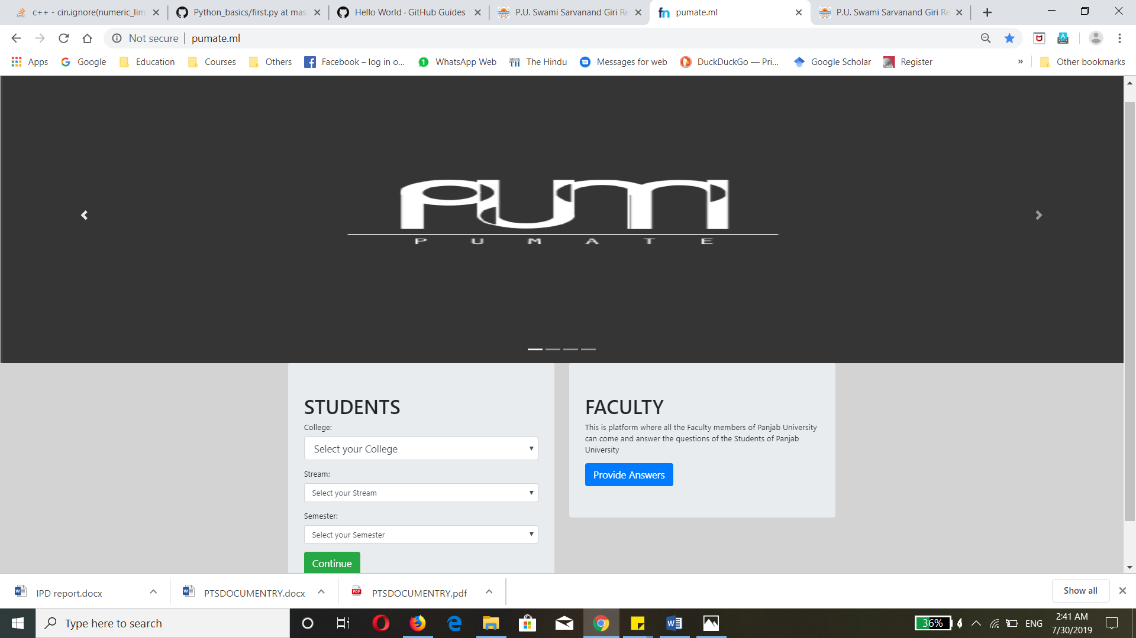

**Inner Home Page**

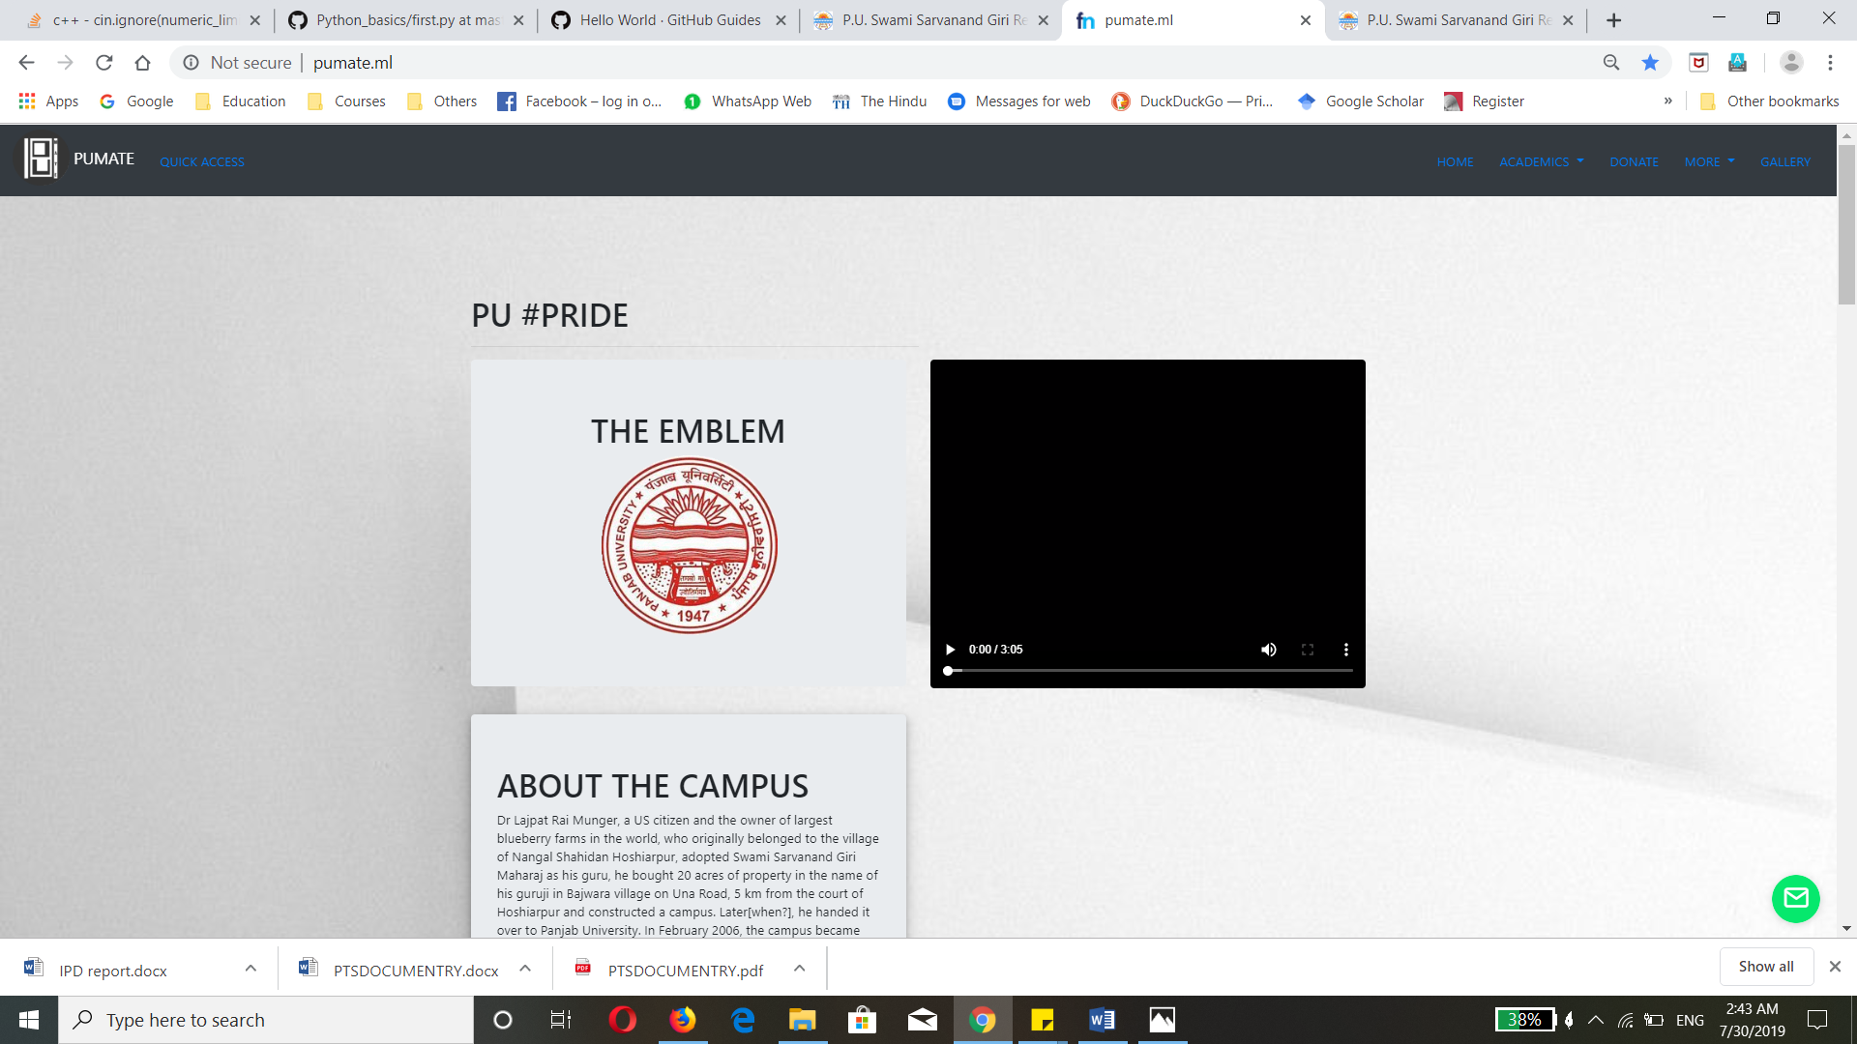

**Upcoming Events**

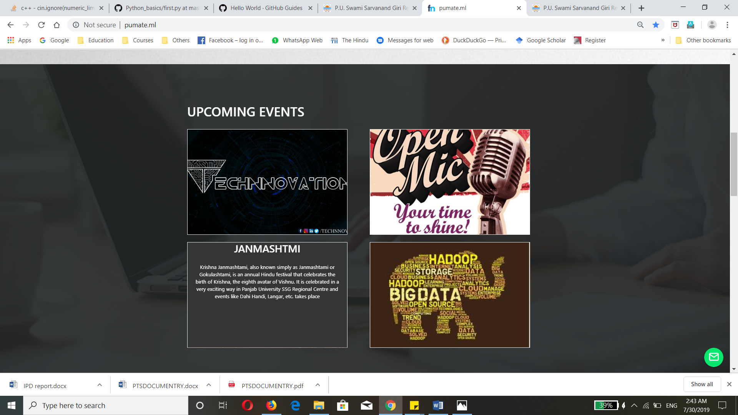

**Older Events**

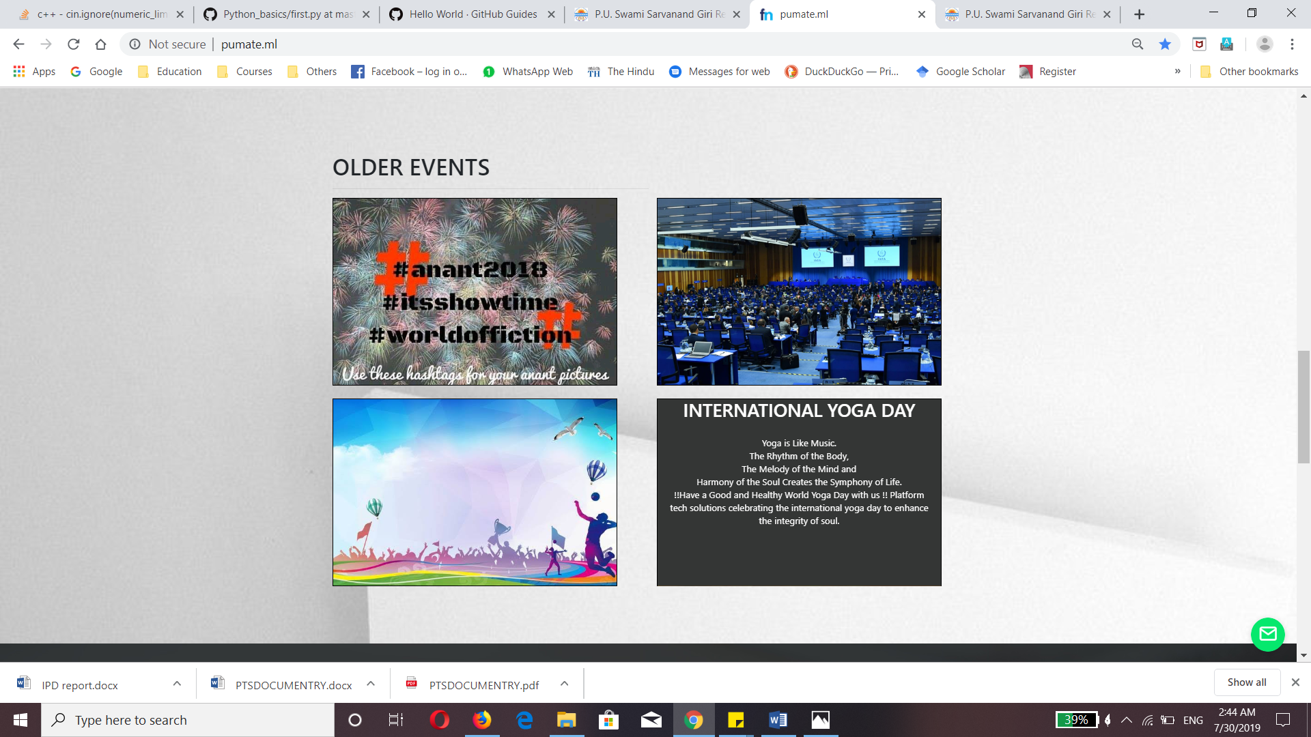

**Question Paper & Syllabus**

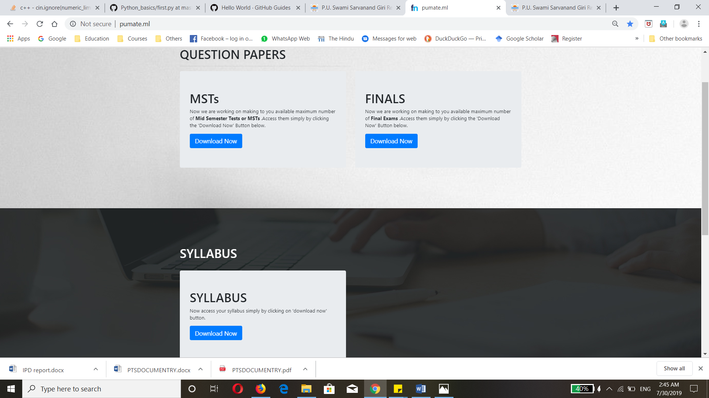

Commities

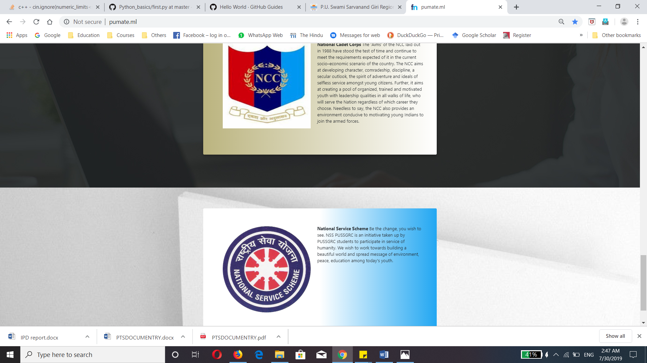

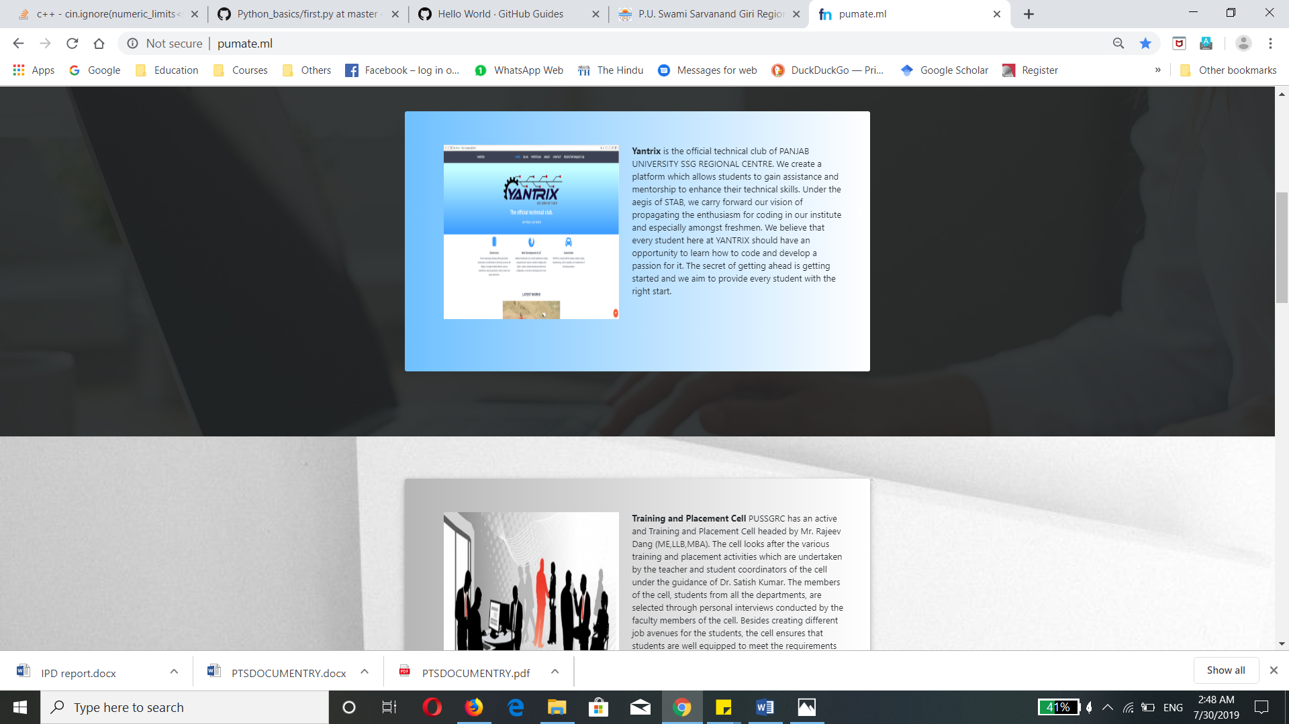

**Enterprenours**

